**Static Routing Topology (Set – A)**

|  |  |
| --- | --- |
| **Name: Devopriya Tirtho** | **ID: 16.02.04.033** |

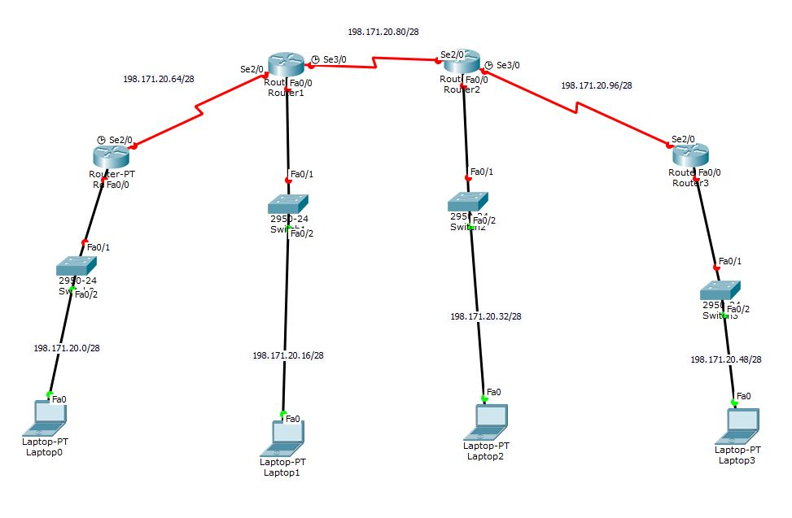

**Task 01: Addressing Table**

|  |  |  |  |
| --- | --- | --- | --- |
| **Device** | **Interface** | **IP address** | **Subnet Mask** |
| **ROUTER 0** | **Fa0/0** | **198.171.20.1** | **255.255.255.240** |
| **Se2/0** | **198.171.20.65** | **255.255.255.240** |
| **ROUTER 1** | **Fa0/0** | **198.171.20.17** | **255.255.255.240** |
| **Se2/0** | **198.171.20.66** | **255.255.255.240** |
|  | **Se3/0** | **198.171.20.81** | **255.255.255.240** |
| **ROUTER**  **2** | **Fa0/0** | **198.171.20.33** | **255.255.255.240** |
| **Se2/0** | **198.171.20.82** | **255.255.255.240** |
|  | **Se3/0** | **198.171.20.97** | **255.255.255.240** |
| **ROUTER**  **3** | **Fa0/0** | **198.171.20.49** | **255.255.255.240** |
| **Se2/0** | **198.171.20.98** | **255.255.255.240** |
| **PC0** | **N/A** | **198.171.20.2** | **255.255.255.240** |
| **PC1** | **N/A** | **198.171.20.18** | **255.255.255.240** |
| **PC2** | **N/A** | **198.171.20.34** | **255.255.255.240** |
| **PC3** | **N/A** | **198.171.20.50** | **255.255.255.240** |

**Task 2: Subnet Information**

|  |  |  |  |  |
| --- | --- | --- | --- | --- |
| **Subnet Number** | **Subnet Address** | **First Host Address** | **Last Host Address** | **Gateway Address** |
| **1** | **198.171.20.0** | **198.171.20.2** | **198.171.20.15** | **198.171.20.1** |
| **2** | **198.171.20.16** | **198.171.20.18** | **198.171.20.31** | **198.171.20.17** |
| **3** | **198.171.20.32** | **198.171.20.34** | **198.171.20.47** | **198.171.20.31** |
| **4** | **198.171.20.48** | **198.171.20.50** | **198.171.20.63** | **198.171.20.49** |
| **5** | **198.171.20.64** | **198.171.20.65** | **198.171.20.79** | **N/A** |
| **6** | **198.171.20.80** | **198.171.20.81** | **198.171.20.95** | **N/A** |

**Task 3: Static Routing Table for Router0**

|  |  |  |
| --- | --- | --- |
| **Network Address** | **Mask Address** | **Next Hop** |
| **198.171.20.16** | **255.255.255.240** | **198.171.20.66** |
| **198.171.20.80** | **255.255.255.240** | **198.171.20.66** |
| **198.171.20.32** | **255.255.255.240** | **198.171.20.66** |
| **198.171.20.96** | **255.255.255.240** | **198.171.20.66** |
| **198.171.20.48** | **255.255.255.240** | **198.171.20.66** |

**Task 3: Static Routing Table for Router1**

|  |  |  |
| --- | --- | --- |
| **Network Address** | **Mask Address** | **Next Hop** |
| **198.171.20.0** | **255.255.255.240** | **198.171.20.65** |
| **198.171.20.32** | **255.255.255.240** | **198.171.20.82** |
| **198.171.20.96** | **255.255.255.240** | **198.171.20.82** |
| **198.171.20.48** | **255.255.255.240** | **198.171.20.82** |

**Task 3: Static Routing Table for Router2**

|  |  |  |
| --- | --- | --- |
| **Network Address** | **Mask Address** | **Next Hop** |
| **198.171.20.48** | **255.255.255.240** | **198.171.20.98** |
| **198.171.20.16** | **255.255.255.240** | **198.171.20.81** |
| **198.171.20.64** | **255.255.255.240** | **198.171.20.81** |
| **198.171.20.0** | **255.255.255.240** | **198.171.20.81** |

**Task 3: Static Routing Table for Router3**

|  |  |  |
| --- | --- | --- |
| **Network Address** | **Mask Address** | **Next Hop** |
| **198.171.20.32** | **255.255.255.240** | **198.171.20.97** |
| **198.171.20.80** | **255.255.255.240** | **198.171.20.97** |
| **198.171.20.16** | **255.255.255.240** | **198.171.20.97** |
| **198.171.20.64** | **255.255.255.240** | **198.171.20.97** |
| **198.171.20.0** | **255.255.255.240** | **198.171.20.97** |